Human Digestive System

A. Alimentary Canal
B. Associated glands – Salivary, Pancreas , Liver

1.Buccal Cavity
- Teeth
- Tongue
- Salivary gland
2. Pharynx and Oesophagus
Pharynx
1.The pharynx is a common passage for both food and air.
2.It connects the mouth to the oesophagus.
3.During swallowing, food passes from the mouth into the oesophagus through the pharynx.
4.A flap-like structure prevents food from entering the windpipe

Oesophagus (Food Pipe)
- 1.The oesophagus is a muscular tube connecting the pharynx to the stomach.
- 2.It does not digest food.
- 3.Food is pushed down by peristalsis (wave-like muscular movement).
- 4.Food moves even if a person is upside down.
Stomach
- The stomach is a thick, muscular, J-shaped organ.
- It temporarily stores food.
- The stomach secretes gatric juice which has 3 substances-
a. Hydrochloric acid – kills germs and helps digestion
b. Digestive juices – digest proteins
c. Mucus – protects the stomach wall
- Food is churned and converted into a semi-liquid form.
Epiglottis
- The epiglottis is a leaf-shaped flap of cartilage.
- It is present at the opening of the windpipe (trachea).
- During swallowing, the epiglottis closes the windpipe.
- This prevents food from entering the lungs.
- When we breathe, the epiglottis remains open.

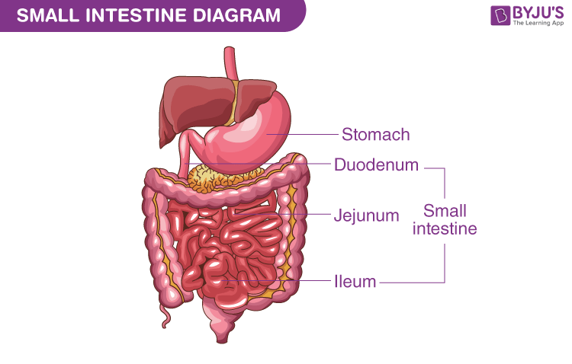

• The small intestine is a long, highly coiled tube.
• It is about 7–7.5 metres long in adults.
• It receives digestive juices from the liver (bile) and pancreas through a common duct.
Liver
• The liver is the largest gland in the human body.
• It is located on the right side of the abdomen.
• The liver produces bile juice.
• Bile is stored in the gall bladder (Sac)
• Bile helps in the digestion of fats by breaking them into small droplets.

Pancreas
The pancreas is a gland located below the stomach.
• It secretes pancreatic juice into the small intestine.
• Pancreatic juice helps in digesting:
Carbohydrates
Proteins
Fats

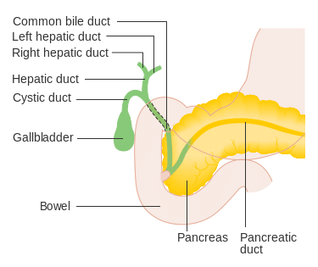

Intestinal Juices
• Intestinal juice is secreted by the walls of the small intestine.
• It completes digestion of food.
• It converts:
Carbohydrates → simple sugars
Proteins → amino acids
Fats → fatty acids and glycerol
• The digested food is then absorbed by villi.

Absorption in the small intestine
• The inner wall has many finger-like projections called villi (singular villus)
Each villus has network of thin and small blood vessels called – capillaries.
• Villi increase surface area and absorb the digested food and passes them to fine blood capillaries.

Assimilation
• Assimilation is the process by which absorbed digested food is used by the body cells.
• After absorption in the small intestine, nutrients are carried by blood to all parts of the body.
• These nutrients are used for:
Growth
Repair of tissues
Energy production
• Example:
Glucose is used by cells to release energy
Amino acids are used to make proteins

